**Battery - Week 8 Video Assignment**

**Due by 3:30PM on Friday, October 27th**

* Videos should be posted directly into the [2023 TU Percussion Page](https://www.facebook.com/groups/626612049531624))
* **Snares will post in Discord for Jordan**

**Snares:**

* Thunder Intro
  + E to F, 3X: Focus on feet timing in the jelly roll and articulating the rhythms in the crescendo right after the jelly roll.
  + H to End, 3X. Focus on the PDD in H3. Check dynamic and articulate the 16th notes in I4.
* Umbrella
  + F to G, 3X. Focus on rhythm and flam spacing in F5
  + [Split 9 Breakdown](https://drive.google.com/file/d/1A593hgnVdJEpPpSRRUT4ABZh_hmfEuPd/view?usp=share_link) 3X w/[Audio](https://drive.google.com/file/d/18ej-JqQE7rSZJ8VqjeDvpdSlrg7TrQjb/view?usp=share_link)

**Tenors:**

* X Factor Tag
  + 3X at 148BPM
* Thunder Intro
  + E to F, 3X: Focus on feet timing in the jelly roll and articulating the rhythms in the crescendo right after the jelly roll.
  + H to End, 3X. Focus on the PDD in H3. Check levels and articulate the left hand paradiddles in I5 and I6.
* Umbrella
  + F5 to G, 5X. Clean!
  + [Split 9 Breakdown](https://drive.google.com/file/d/1A593hgnVdJEpPpSRRUT4ABZh_hmfEuPd/view?usp=share_link) 3X w/[Audio](https://drive.google.com/file/d/18ej-JqQE7rSZJ8VqjeDvpdSlrg7TrQjb/view?usp=share_link)

**Basses:**

* Umbrella
  + [Split 9 Breakdown](https://drive.google.com/file/d/1A593hgnVdJEpPpSRRUT4ABZh_hmfEuPd/view?usp=share_link) 3X w/[Audio](https://drive.google.com/file/d/18ej-JqQE7rSZJ8VqjeDvpdSlrg7TrQjb/view?usp=share_link)
  + F to G, 3X. Part change in F5.

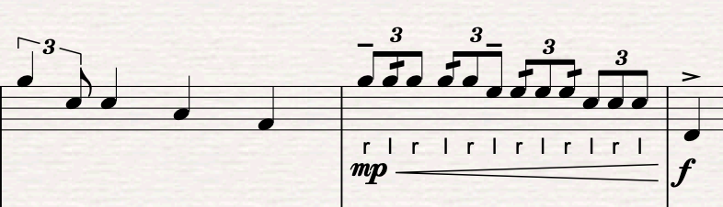

* Lobster
  + Feature 3X w/Met

**Cymbals:**

* [Lobster Feature Tempo Check](https://drive.google.com/file/d/1q8PWu7xDW2nl6PLTZJV0FiWG3GAiwSeA/view?usp=share_link) w/[Click Track Audio](https://drive.google.com/file/d/1H5VYZpAqzvijbudCrmrkpudIW_daxgk-/view?usp=share_link): Focussing on tempo maintenance.
* Shoes, B-End: 2X
* Maryland Medley, M-End: 2X